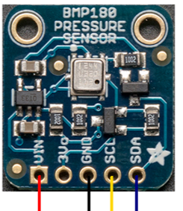

We used the BMP180 I2C sensor for both temperature and pressure.

1. Link on youtube:

[https://www.youtube.com/watch?v=tcdbCTNQkMU](https://l.facebook.com/l.php?u=https%3A%2F%2Fwww.youtube.com%2Fwatch%3Fv%3DtcdbCTNQkMU&h=aAQGLwo15)

In this video we are testing the circuit by measuring the temperature between 99 and 102 Fahrenheit degree.

1. Circuit design and simulation:

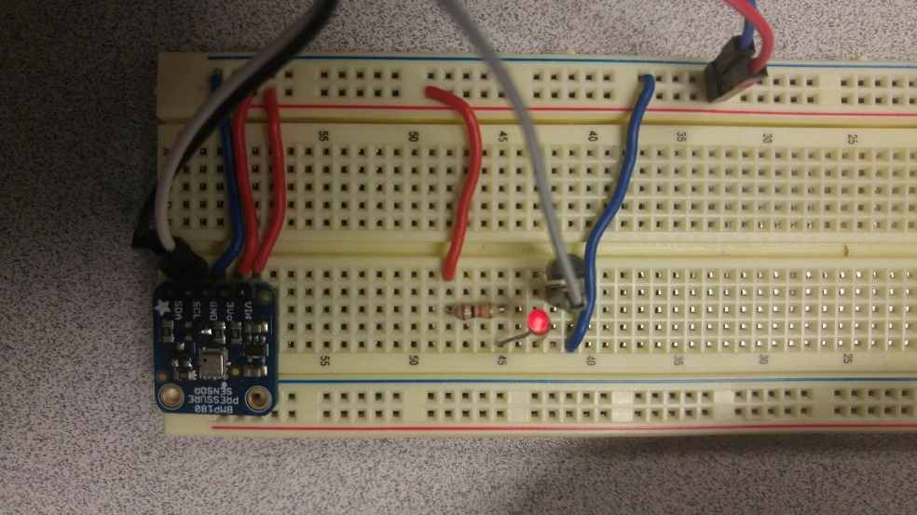

3.3 V & GND

1K Resistor

BS270 Transistor

LED

BMP1800 I2C Sensor

* This is the circuit design for our lab: as you can see the LED is on and it indicates that the temperature is out of range. In the video you will see when the temperature is in range and the LED is off.

1. Analysis of pitfalls and how to overcome those; system working without a computer attached to it

* we wanted to implement an automated twitting system that would notify all followers on a twitter account about the status of Chicken eggs. Unfortunately the Beagle bone was having issues with Twegde(Twitter application for pushing notifications) and we were not able to complete this task. The next step to automate our IOT system was to install a wireless wifi USB (we didn’t end up buying the part <http://www.amazon.com/NETGEAR-Wi-Fi-Micro-Adapter-WNA1000M/dp/B004VDR37K> ). We wanted our system to be fully integrated to a high speed data acquisition service like Thingspeck. We would also connect the Beaglebone to a 5v barrel adapter to have it powered through a wall socket.